Herrold FLA Conference Grant Application
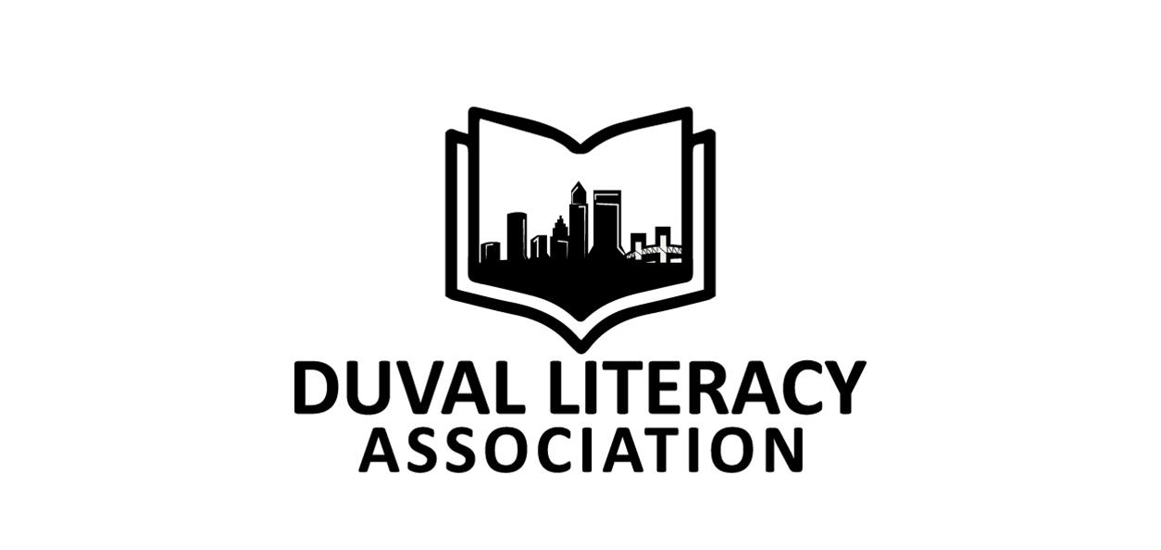
Information
The Duval Literacy Association is pleased to announce the availability of a professional development grant for attendance to the 2019 Florida Literacy Association Conference to be held Saturday and Sunday, November 2‐3, 2019, in Orlando. Optional pre-conference institutes are on Friday afternoon, November 1st. The value of the grant is $200. The grant will be awarded prior to the conference and the recipient will be notified on or before Friday, October 18, 2019.
The grant is named in memory of Dr. Bill Herrold, Professor Emerita, University of North Florida, and a past president of both Duval County Reading Council and Florida Reading Association.
Purpose This grant helps offset the costs associated with attending the FLA Annual Literacy Conference. Funds may be used for conference registration, travel, hotel, or per diem expenses. Expenses in excess of the grant will be the responsibility of the grant recipient or the school district.
Eligibility Applicants are those who are employed by a school or district and teach reading and/or writing all or a portion of the day. Applicants may also be employed as reading interventionists, ESE teachers, or school-based/district-based literacy coaches. Applicants must be current members of Duval Literacy Association. Previously awarded grant recipients must wait two years to reapply.
Criteria Applications will be judged on the following criteria:
• Written essays (worth 70 points)
• Supervisor recommendation (worth 30 points)
Responsibilities of Recipient
• Attend the 2019 Florida Literacy Association Annual Conference.
• Share the experience and learning with colleagues.
• Submit a brief essay to DLA describing the impact of the grant within one month of attending the conference.
• Give permission to DLA to copy any portion of the essays to the grant sponsor, if applicable, and use any portion in a DLA publication, including the web site or other social media platform.
• Send a photo and give permission to DLA to use it in any DLA publication, including the web site or other social media platform, or to provide it to the grant sponsor, if applicable.
IMPORTANT GUIDELINES FOR SUBMISSION
The 2‐page Application Form and supervisor’s letter of recommendation are to be combined into one PDF and emailed as one attachment by Friday, October 11, 2019. Incomplete applications will not be considered. All applications become the property of DLA and will not be returned.

Submit application packet by email to Audrey Carroll at dla.awardsandgrants@gmail.com.
Subject line: Herrold FLA Conference Grant Application
Please text or call Audrey at 404-625-2972 with any questions.

Herrold FLA Conference Grant Application

Contact Information
Name
Mailing Address – Line 1
Mailing Address – Line 2
Daytime Phone Number
Evening Phone Number
Email
School/Work Location
Position/Title
Principal/Supervisor
Principal/Supervisor Email

_____ I certify that the information in this application is accurate.

_____ I understand that all required materials must be emailed and received electronically by Friday,
October 11, 2019 for my application to be considered.

Applicant’s Signature _________________________________________________ Date ________________
Application-Page 1
Herrold FLA Conference Grant Application

Essays
Each essay is limited to 100 words or less.
Essay 1. What new insights do you expect to gain from attending this event? (20 points)

Essay 2. How will you share what you learn with your colleagues? (20 points)

Essay 3. Describe your funding needs and show the budget for conference attendance. (30 points) For example, list your expected expenses and explain what portion of those expenses you anticipate will be covered through work-related sources.

Recommendation from Supervisor/Principal
4. On official letterhead, please have your supervisor write a brief letter of recommendation on your behalf. The letter must state that you are currently working in a literacy-related field. This letter must be converted and combined with your application form in one PDF. (30 points)
Application – Page 2

